To access the Client Portal, please use https://rhwcpas.com/client-portal
You will be directed to this page, click the White letter “this link”
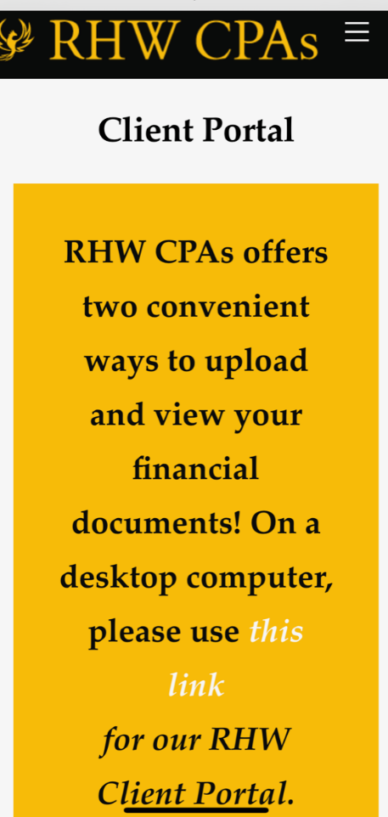

This will take to log in screen,
We do not recommend that you download the app at this time, but use your browser.
The log in screen look like this, you can add the Multi-Factor auth if chose to, or can click: Reminde me later”
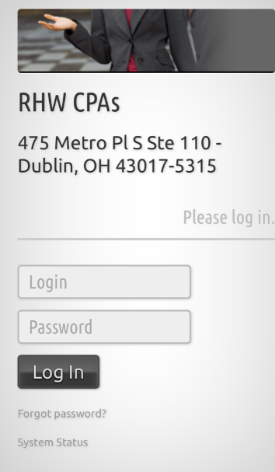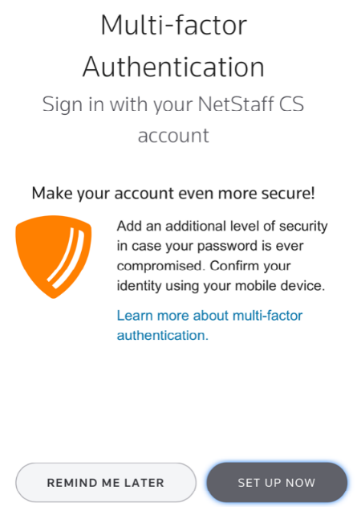

You will then be taken to your home page of the portal.
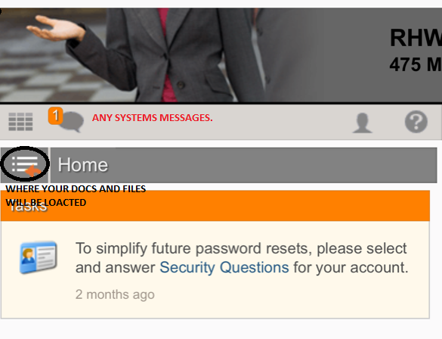
The Message box will have system generated notices. You will be prompted to updated your pass word from time to time.
The file folder next the word “HOME” will be where your documents will be.

Will look like this
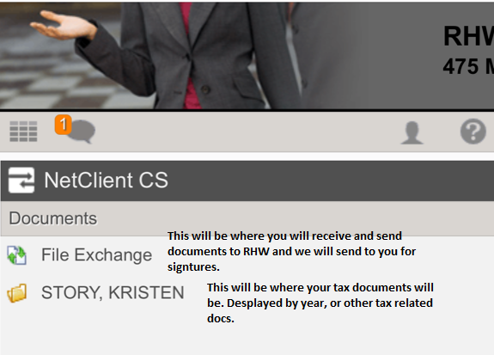
The File exchange will have two files
Actionable Items From RHW: this will be where we send you documents that need to be signed and returned to us. I.E E- file forms.
Documents to RHW: this where you will send documents, like tax back up docs to RHW.

The file with your personal or company name will contain your actual tax returns. They will be labeled “Tax returns” and by year.

To send Documents, you click on Documents to RHW:
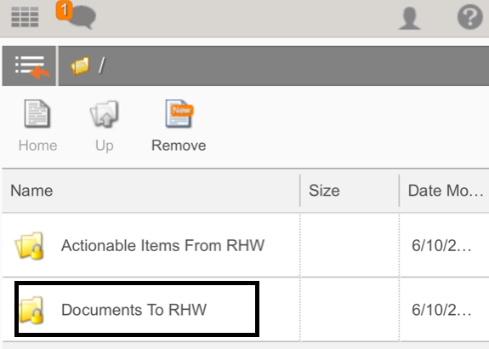
Click the “Upload” icon
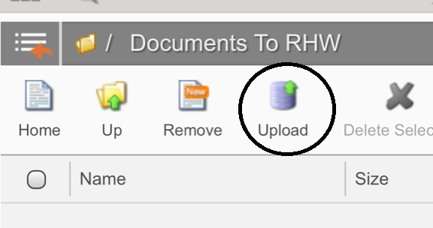
Then Drag you documents or Browse your computer to get the desired documents.
And select upload.
We will be notified they are there, and move them to our files.

